Acetylene ALARP Demonstration for Continuous Operation in

‘High Throughput’ Unit

Shell Technology Centre Bangalore (STCB)
Date: 7th September 2021

Document History
Date | Issue | Reason for Change
10/05/2021 | 0 | Issued for review
07/09/2021 | 1 | Issued for approval

Document control
Author | Position
Prakhar Patel | STCB HSSE Advisor
Vikrant Urade | Sr Engineer Chemical Lead Gen (Emerging Technologies)
Andrew Horton | Senior Researcher Experimentation (Emerging Technologies)

Review / TA3 Approval | Position
Andrzej Pekalski | Snr Technical Safety Eng - Major Hazards

Synopsis
Acetylene (H-CΞC-H) is proposed to be used as part of a mixture of gases in continuous mode in the high-throughput reactor unit developed by ILS (Integrated Lab Solutions GmbH) to carry out a range of chemistries, including hydrogenation, carboxylation, hydroxycarbonylation, and cyclotrimerization.
The experimentation is sponsored by M2P (Methane to Products) program under the Long-Range Research platform and will be carried out in the Emerging Technologies (ET) team (PTX/C/T) in STCB.
The M2P program is split into three stages:
- Stage 1: Acetylene mixed with inert gas for experimentation in modified MCSR (micro catalytical screening reactor) unit as well as batch setup in Parr autoclaves. These experiments have already started in ET lab in STCB.
- Stage 2: Acetylene mixed with reactant gases (CO, CO₂, H₂ etc.). This requirement applies to the continuous mode ILS high-throughput reactor system.
Acetylene is widely used in the industry for chemical syntheses as well as for welding applications. It is a thermodynamically unstable molecule at conditions of elevated temperature and pressure, and it has the property to decompose, releasing energy. Depending on various factors such as the vessel size and geometry, quantity of acetylene, external cooling applied, the decomposition may be a deflagrative or a detonative one.
In the case of unstable compounds like acetylene, after ignition, energy can be released in decomposition process in the absence of an oxidant, in a similar mode to the propagation of the flame front in case of combustion of hydrocarbons in the presence of O₂.
Therefore, in case of acetylene mixture with a diluent (diluent is acting as an inert gas) there is only one flammability limit which is the flammability limit at given temperature and pressure. This is in contrast to the HC/air mixtures, where there are two flammability limits.
The intention of the project is to operate outside the flammable range of acetylene/diluent mixtures of interest under desirable experimental conditions.
The high throughput unit, which will be used to carry out the chemistries involving acetylene, consist of three main sections: feed (gaseous as well as liquid), reaction, and downstream. The compressor is part of the feed section and it is used to compress the pre-mixed feed gases to the desired operating pressure. Acetylene mixtures with other gases can be delivered at a certain cylinder pressure, which depends on the composition (volume percentage of acetylene in mixture), such that the acetylene partial pressure is below a certain maximum. To ensure optimal utilization of cylinder contents, especially considering long delivery times for such mixed gas cylinders, the cylinder pressure would be dropped to a low suction pressure (circa 1-2 barg) and then re-compressed up to the maximum cylinder pressure.
A Desktop Safety Review was carried out on the High Throughput Unit, and one of the key scenarios identified was the potential decomposition of acetylene at the compressor outlet or within the compressor itself due to increased temperature and pressure.
Under this mode of operation, there two types of ignition sources:
- Self-ignition (or self-decomposition for unstable compounds without oxygen) due to high temp when a mixture is in contact with environment of sufficiently high temperature, which may induce an exothermic reaction and,
- Ignition due to high density energy source, typically mechanical, electrostatic etc. When a spark releases sufficient energy, flame propagation may occur through the mixture. If mixture is not flammable, such ignition source is not effective.
Therefore, the concerned mixtures were analysed with respect to both thermal stability at elevated conditions (pressure and temperature) as well as flammability. A detailed kinetic model (DKM) [Ref 6] was used to analyse the thermal stability of the given worst-case mixture compositions at corresponding experimental conditions. A verification of the model was obtained using pure acetylene as given in APPENDIX 1. Considering the paper of Cullis [1963] [Ref 5] which investigated the pyrolysis of pure acetylene (so the self-decomposition) at temperature range from 500 to 1000 °C and atmospheric pressure. The lowest noticeable decomposition of acetylene occurred at 500°C. The agreement with the experimental value obtained in a well-defined laboratory conditions is considered as very good. It is worth mentioning that the Temperature (AIT), i.e., the lowest temperature at which the most sensitive acetylene air mixture undergoes self-ignition is around 320°C. However, temperature at which pure acetylene undergoes self-decomposition called Auto-decomposition Temperature, ADT, is 635°C. As expected, presence of air lowers the ignition temperature, the effect is significant: 300 °C. difference. In the absence of air, in a non-adiabatic measurement system the ADT is 635°C (at atmospheric pressure). Hence, the theoretical prediction is relatively accurate. The corresponding documents indicating the ADT, AIT values are given in [Ref 10], [Ref 11], [Ref 12], [Ref 13].

For the mixed gas cases related to operation of the unit, eight different compositions of acetylene with diluents, provided in Section 1.8, were considered. The worst-case composition, #8 (C2H2: 16 mol%, T: 150°C, P: 15 bara) was analysed for potential self-decomposition at the compressor outlet within time span of 10 min, using the detailed kinetic model and the worst-case assumption i.e., adiabatic condition. The calculations revealed that the mixture may self-decompose at a temperature much higher than attainable at the compressor discharge, what is consistent with ADT of 635°C (at atmospheric pressure). Furthermore, flammability of the mixtures was analysed at the compressor outlet. The conclusions are given in the table below:
Mixture no | Flammability
1 | NOT flammable
2 | NOT flammable
3 | NOT flammable
4 | NOT flammable but close to flammability
5 | Potentially slightly flammable
6 | NOT flammable
7 | NOT flammable
8 | NOT flammable
Table 1: Flammability of various mixture compositions
It is proposed to reduce the Acetylene concentration for composition 4 & 5 to avoid any possibility of operating in a flammable regime, however, the flammability assessment is considered conservative.
In case of an upset scenario, the mixture composition may be rendered flammable due to elevated temperature and pressure. However, the ignition may be effective only in the presence of a strong ignition source, as outlined in the ALARP demonstration for batch reactor setup [Ref 1]. The presence of such an ignition source is unlikely given the system will be well grounded / bonded. Moreover, the adiabatic assumption is not realistic as the large surface to volume ratio of the compressor discharge section facilitates heat loss, lowering the temperature after compression.
For the pure acetylene case, the temperature at which acetylene starts decomposing within 10 min at varying initial pressures and temperatures was estimated using a detailed kinetic model. As per the kinetic model, at 5 barg, acetylene starts to decompose within 10 min at a temperature of 452°C. This temperature is higher than the maximum temperature attainable at the compressor discharge (under adiabatic conditions), and even the temperature difference is even larger when compared to ADT of pure acetylene, equal 635 °C (at atmospheric pressure). Hence, the likelihood of decomposition of acetylene in a mixture with an inert gas is very small (presence of inert gas increases ADT).
In the unlikely event of self-decomposition of the flammable mixture, the calculated deflagrative maximum overpressures for the given compositions are below the design pressure of the system on the discharge side of the compressor. A rupture disc is installed in proximity to relieve a potential pressure excess. It is recommended to set the opening pressure of the rupture disk at a value slightly higher than normal operating pressure (~ 20 %), to prevent any unwarranted pressure build-up in the system, which could lead to flame propagation downstream. The release will take place into the site EMV (emergency vent header) which is continuously purged with N2 to ensure no re-ignition and explosion in the system.
To eliminate any residual risk of rapid pressure build-up leading to rupture of equipment and to prevent fragments flying into the room a polycarbonate enclosure is provided around the compressor section. The polycarbonate enclosure should capture the flying fragments; hence it should prevent a person who may be nearby from being hit.
Further to the due diligence from the cylinder supply vendor as well as the assurance at their end, it is agreed that the composition from the new cylinder will be routed to GC analysis before feeding into the unit. This step will be incorporated in the unit SOP as a critical step. Such a barrier should eliminate the scenario of higher acetylene concentration in the feed.
Risks related to the release of mixtures into the air are covered as per STCB site philosophy as defined in Section 1.1.
Contents
Document History 2
Executive Summary 3
1.1. Background 8
1.2. Description of the Unit 9
1.2.1. Feed Section 9
1.2.2. Reactor Section 13
1.2.3. Downstream Section 13
1.3. Scope 15
1.4. ALARP Decision Type 16
1.5. Chemistries Involved 16
1.6. Flammability with Unstable Compounds 17
1.7. Acetylene Properties 17
1.7.1. Diluent Effect 18
1.7.2. Ignition Type and Energy 20
1.7.3. Equipment Geometry 21
1.8. Analysis of Pure Acetylene Chemistries 21
1.8.1. P0=1 bara 22
1.8.2. P0=2 bara 22
1.8.3. P0=5 bara 22
1.9. Analysis of Mixed Gas Composition Chemistries 23
1.10. Options Considered 25
1.11. Justification for the Chosen Option 26
1.12. Uncertainties and Escalation Ladder 26
1.13. Requirements/Recommendations 27
References 29
Bibliographic information 30

Background
The M2P program under Long Range Research platform aims at developing technologies for valorisation of methane-containing gas (e.g., natural gas, NG), renewable natural gas (RNG), refinery off-gas, fuel gas from petrochemicals complexes etc.) into more valuable chemicals. In the long-range scenario, the price of renewable electricity is expected to decline, with predictions of electricity price as low as 1 cent/kWh. Price of methane containing gas streams is also expected to decline as both electricity and heat is increasingly produced using renewable, non-hydrocarbon resources. Thus, methane-containing gas streams are expected to become advantaged feedstocks for chemicals in the future.
Acetylene (H-CΞC-H) is a molecule that can be produced readily from methane-containing hydrocarbon streams using electricity as input – for example, directly using the thermal plasma reactor system or indirectly by first pyrolyzing methane to carbon and hydrogen and using carbon as an input to the calcium carbide process to make acetylene. Acetylene is a versatile chemical intermediate that can be converted into a range of molecules of interest to Shell – such as ethylene, butadiene, 1,4-butanediol, acrylic acid, acetic acid, benzene, styrene and potentially other high value chemicals.
Given this background, M2P program under the Long-Range Research platform has funded a series of experimental activities in Emerging Technologies team (PTX/C/T) in Bangalore and in Amsterdam. The Emerging Technologies team is augmenting its R&D infrastructure to be able to cater to these R&D programs. This includes modification of existing assets – MCSR and Parr autoclaves, as well as procurement of new assets. New assets being procured in 2020 include two additional Parr reactor systems and one high-throughput fixed bed reactor system with eight parallel reactors (supplied by ILS GmbH, Germany) as described in section 1.2.
The M2P program on acetylene conversions is split into three stages:
- Stage 1: Acetylene mixed with inert gas for experimentation in modified MCSR unit as well as batch setup in Parr autoclaves. These experiments have already started in ET lab in STCB.
- Stage 2: Acetylene mixed with reactant gases (CO, CO₂, H₂). This requirement applies to the continuous mode ILS high-throughput reactor system.
The purpose of this document is to provide a basis for demonstrating ALARP for the mixed gas composition as outlined for stage 2.

Description of the Unit
The High-Throughput Fixed Bed Parallel Reactor System, or simply the high-throughput reactor system, comprises of three main sections:
      - Feed section
      - Reaction section
      - Downstream section
A schematic of the high-throughput unit is shown in Figure 1.

Feed Section
The feed section of the high-throughput unit can be divided into two parts: (i) gas feed section and (ii) liquid feed section. The unit has been designed to be flexible in the choice of various feeds and includes an in-built ability to select one or more feeds and dose them into the reaction section in a controlled manner.
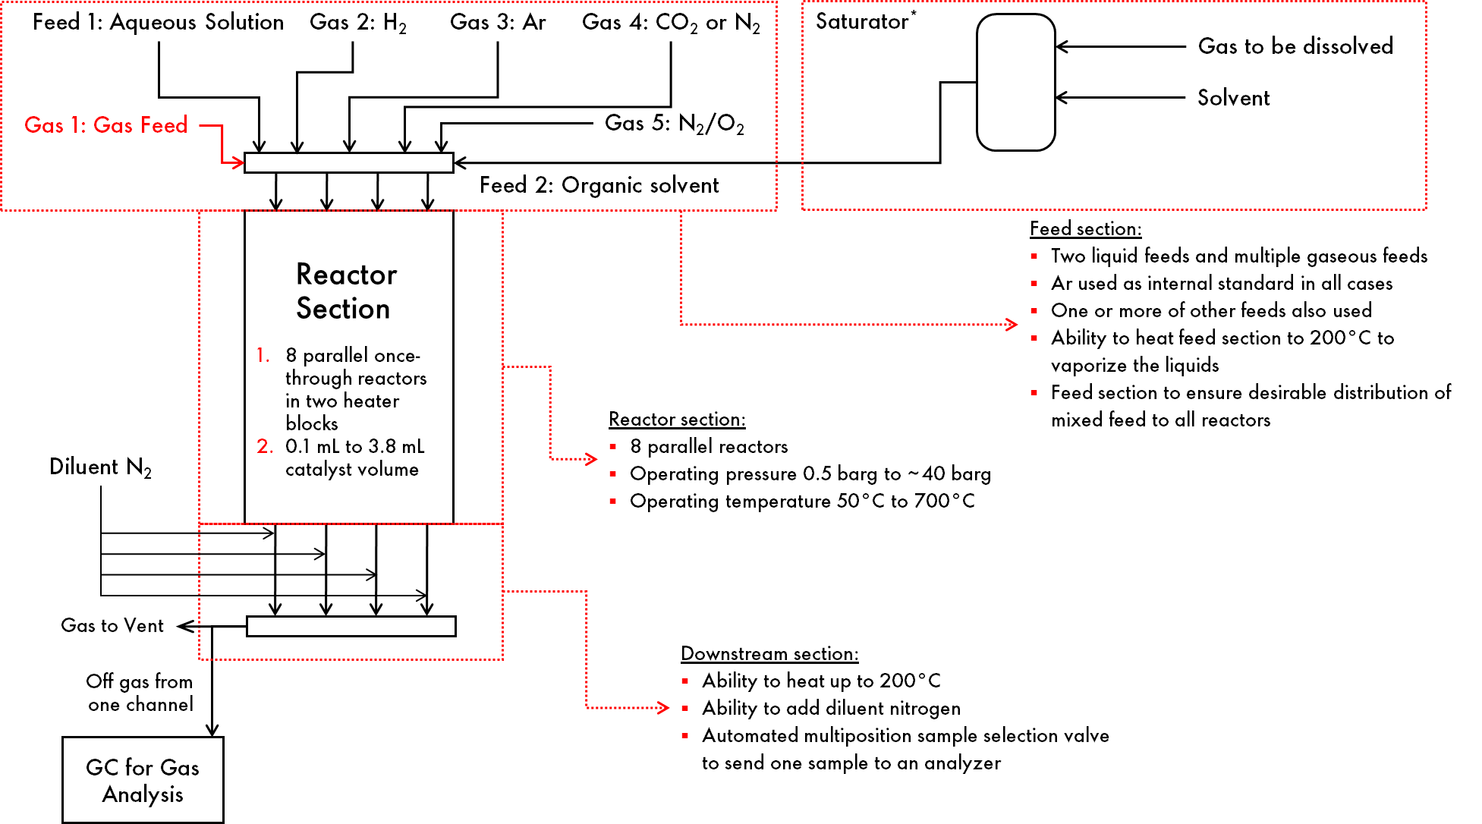
Figure 1 Schematic of the high-throughput reactor unit

Gas Feed Section
The gas feed section has the ability to select one or more of the feeds below, mix them in a desirable ratio and send the mixed gas to compressor suction.
      - Acetylene-containing mixed gas
      - Hydrogen
      - Methane
      - Ethane
      - Ethylene
      - Argon
      - Nitrogen
      - Carbon dioxide, (CO₂)
      - Carbon monoxide, (CO)
The compressor then compresses the mixed gas to a target pressure. Regardless of the mixture composition, the maximum target pressure at compressor discharge is equal to the cylinder supply pressure of the mixed acetylene containing gas. That is, if the mixed acetylene containing gas cylinder was supplied by the gas supplier with a pressure of, say, 15 barg, the discharge pressure shall be limited to 15 barg. In other words, we will not take credit of additional dilution offered by other diluent gases and do the ALARP analyses based on composition of the acetylene-containing gas supplied from the mixed gas cylinder.
The compressor suction has a low-pressure volume bottle of 1000 mL volume, with a design pressure of 124 barg at a design temperature of 426 °C. Suction bottle pressure is controlled by controlling the flow rate of the individual gas streams mentioned above, and a ratio control is used for the flow controllers, so all gases are delivered in a fixed proportion and a stable composition at compressor suction is achieved. As the consumption of the gases downstream of the compressor changes, for example if the flow rates to reactor are increased, flow controllers deliver more flow to the suction bottle but in a fixed ratio to maintain stable pressure.
Given rather small flow rate of gases in this unit, all tubing is ¼” Swagelok tubing, and compressor end connections are ¼” NPT.
Compression is achieved using two compressors in series: A Haskel AGT-4 followed by a Haskel AG-15. Both are small, air-driven reciprocating compressors. AGT-4 is a two-stage machine with a maximum rated discharge pressure of 86 barg, and piston displacement per cycle of 164 mL. Interstage pressure is calculated based on inlet pressure and target discharge pressure after second compressor so as to achieve similar compression ratios for the two compressors. AG-15 is a single acting single stage compressor with a maximum rated pressure at the discharge of 155 barg. It has a piston displacement per cycle of 101.6 mL. The maximum pressure the compressor can deliver for such pneumatically driven compressors is limited by drive (air) pressure and suction pressure – allowing for a layer of controls and safeguards that can use drive pressure to control the final pressure. These controls and safeguards are illustrated in Figure 2. As explained above, the operating philosophy involves reducing the pressure of acetylene-containing mixed gas from cylinder pressure at delivery (say, P₀) to about 1-2 barg, and recompressing to a maximum pressure of P₀. At the time of writing of this ALARP report, we don’t intend to take any credit for additional dilution offered by mixing of other gases with the acetylene-containing mixed gas from the cylinder during this HSE assessment. If, during any future safety assessments, it is established that pressures higher than P₀ are safe pressure to compress to, this ALARP report will be updated with the assessment and higher pressures allowed. It should be noted at this point that entering the target pressure set point is an operator action, and suitable safeguards such as supervisory control over this action, need to be established while developing the operating protocols.
Each compressor is equipped with a burst disc immediately downstream of the compressor. For the first compressor, the burst pressure 15 barg, whereas for the second compressor, it is 40 barg. Between the two compressors, there is a section of tubing that is left open to air. This section effectively functions as an air-cooled heat exchanger and brings the temperature down to nearly ambient temperature. There is a safety thermocouple (01i13TIZA02) which shuts down the compressor is the interstage temperature exceeds 35 °C.
The compressed gas is accumulated in a buffer vessel of 500 mL capacity rated for 1450 psi (about 100 bar) at 50 °C. This vessel and the second compressor are protected by the same burst disc rated for 40 barg. The compressed gas is then delivered to individual reactors using eight individual mass flow controllers. Normal operation will involve same feed rate for all reactors, although in principle it’s possible to have a separate flow rate for each reactor without any change in hardware or operating procedures. The flow meters downstream of the compressor control the flow, whereas those upstream of the compressor control the suction pressure, and thus they operate independently.

Organic Liquid Feed Section
The organic liquid feed section comprises of two vessels, one inline and one on standby, containing up to three litres of an organic liquid. The organic liquid can be a reactant itself (e.g., it may be a liquid that is subjected to hydrogenation in the unit), or it may be a solvent that can dissolve acetylene and feed acetylene as a dissolved gas. During the design stage, we expected Stage-3 involving pure acetylene supply would be in place when the high-throughput unit is commissioned, and hence provided the liquid vessels with a low-pressure acetylene supply line. However, at present, we don’t have plans to supply pure acetylene and hence this ability of using dissolved acetylene in effect does not exist anymore. We expect to upgrade the liquid vessels, and any other components in the organic liquid feed section, to a higher-pressure rating, and use mixed acetylene containing gas (e.g., acetylene-nitrogen mixture) to generate acetylene solutions in the future.
Cooling is provided for the organic solvent vessels, and for the lines going up to the pump inlet, to keep acetylene dissolved in the solution and minimize chances of cavitation. The cooling is achieved by using a chiller which is part of the unit.
The organic liquid is pumped into the reactors using an HPLC pump, with an Equilibar downstream of the pump controlling the pump discharge pressure. Eight Coriolis mass flow controllers take the liquid from this constant pressure and dose it into the reactors. Normal operation involves same liquid flow rate for all eight reactors, however in principle it is possible to have individual flow rate control for each reactor with the same hardware and control logic.

Aqueous Liquid Feed Section
Water, or an aqueous feed, can be pumped into the eight reactors as well. Water is stored in two three litre vessels as well, however these are always at ambient temperature. It is pumped into the reactors using an HPLC pump, and flow is equally divided using a capillary distribution system. Based on flow rate necessary, a low pressure drop capillary set and a high pressure drop capitally set is provided – operator needs to manually choose which capillary to use using a 3-way valve. Unlike the gas feed system or organic liquid feed system, the aqueous feed system always, by design, delivers the same flow rate to each reactor.

Reactor Section
The unit contains eight parallel reactors, placed in two heater blocks of four reactors each. Thus, in principle, it’s possible to apply two different temperatures simultaneously and screen many process parameters and catalysts at once. The reactors supplied with the unit have a catalyst volume of 0.1 mL to 3.8 mL per reactor and made of SS316L with Silconert coating or of quartz. SS316 reactors are rated for a maximum operating pressure of 40 barg and maximum operating temperature of 500 °C. Quartz reactors are rated for higher temperature of 700 °C but can operate at low pressure (<0.5 barg) only. It is also possible to obtain reactors of Inconel which are rated for both high temperature (700 °C) and high pressure (40 barg), and we intend to procure those in 2022. At this point, operator controls are needed to ensure suitable reactors are chosen based on the target operating conditions. The reactors are housed in the heater block, which in turn is housed inside an oven.

Downstream Section
The section downstream of the reactor comprises of nitrogen dilution (nitrogen is added downstream of each reactor optionally to keep the products in the gas phase), high-pressure condenser (50 mL vessel per reactor in which gas-liquid separation takes place), selector valves to select one stream for analysis using an online GC, and an Equilibar which controls the pressure for all eight reactors. The draining and collection of liquid accumulated in high pressure gas liquid separators is a manual activity. The mixed product gas after the Equilibar is cooled using cooling water, and any condensed hydrocarbons/liquids are collected in an accumulation vessel (a 10-litre polypropylene carboy, essentially ‘waste liquid’) before the rest of the gas is sent to on-site incinerator.

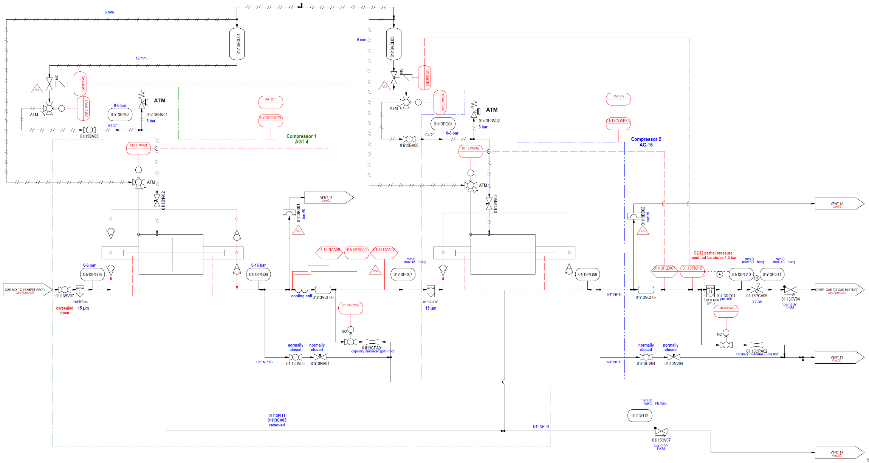
Figure 2 Schematic of controls and safeguards for the compression section of the high-throughput unit

Scope
The scope of this document is limited to the use of acetylene in lab/IPP units for carrying out various chemistries. Acetylene cylinder storage is outside the scope of this document. The scenarios with highest perceived risk were considered for ALARP assessment.
A Desktop Safety Review was carried out on the high throughput unit, and one of the key scenarios identified is the potential self-decomposition of acetylene at the compressor outlet due to increased temperature and pressure. In normal operation, the gas mixture would be compressed up to the cylinder pressure, as described in Gas Feed Section above. The temperature will rise to some extent due to compression. For very small lines of ¼” diameter and small size equipment in this unit, we expect to operate far from adiabatic region. However, for the simplicity of calculations and to ensure we err on the safe side, we assume adiabatic compression. The following table shows the key scenarios identified, where risk of acetylene decomposition is highest.
Section | Specs | Scenario Description
Compressor | ~100 cm3 capacity  Design pressure: 150 barg | High temperature and pressure at the outlet of the compressor due to adiabatic compression, leading to decomposition of Acetylene.
Reactor (quartz) | 4mm tube  Design pressure 12 barg in case of quartz reactor. | High Temperature in Reactor due to any of the following initiating events, leading to a runaway reaction:  (1) Wrong feed gas composition  (2) High feed gas flow  (3) High catalyst activity  (4) Reactor temperature controller failure 10i2TIC02 as given in the P&ID  (5) Wrong reactor temperature control set point due to operator error  (6) Wrong/incompatible catalyst in the reactor  (7) Tube rupture in the reactor leading to LOPC and fire  The reactor is a 4mm tube, which implies high surface to volume ratio – high heat dissipation. Moreover, reactor is enclosed inside furnace, covered by a metal enclosure, which will prevent injury in case of rupture of the reactor and potentially flying objects. Hence, this is not the governing scenario. The risk is already ALARP.

ALARP Decision Type
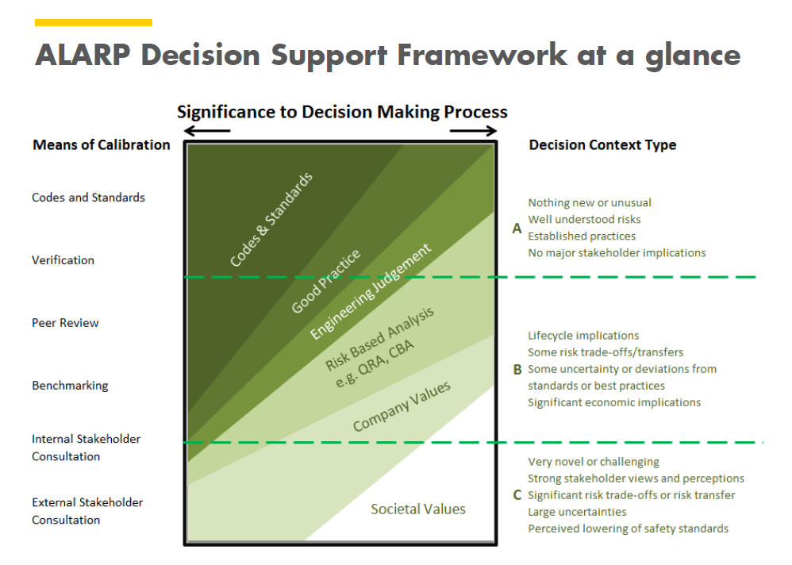
In the present case, the decision context type is a type B decision due to:
- Risk trade-offs (locating units in IPP area) where personnel could be present around the unit. In the worst case, an accidental explosion inside the equipment may lead to personnel injury due to flying pieces of ruptured equipment (for example, rupture of the quartz reactor). Overpressure due to release from such a small source is expected to be negligible.
Consequence of internal deflagrative decomposition of acetylene has been estimated as part of the study.

Chemistries Involved
ILS high-throughput reactor system will be used to carry out a range of chemistries in continuous mode including
          - Hydrogenation of acetylene to ethylene and butadiene
          - Acetylene carboxylation to acetylene mono- and di-carboxylic acids, and subsequent conversion of these acids to molecules of interest such as acrylic acid, 1,4-BDO etc.
          - Acetylene hydroxycarbonylation to acrylic acid
          - Acetylene cyclotrimerization to aromatics (mainly, benzene, styrene)
The unit shall also be used for some non-acetylene chemistries, which are not within the scope of this ALARP. These chemistries are similar to non-acetylene chemistries already practised at STCB. The risk of those chemistries is already covered by the HAZID, DSR and HAZOP completed.

Flammability of Unstable Compounds
Flammability limit is defined as the mixture concentration at which sustained flame propagation is not possible considering mixture concentration at given pressure and temperature. Sustained flame propagation results in energy release which may cause an explosion. Typically for hydrocarbons/air systems there is a Lower and Upper Flammability Limit. At the Lower FL (LFL) there is still not enough fuel in air, hence not enough energy is released for sustained flame propagation. At the Upper FL (UFL) there is not enough oxygen to release sufficient amount of energy for sustained flame propagation.
However, in the case of unstable compounds like acetylene, energy can be released in decomposition process in the absence of an oxidant, in a similar mode to the propagation of the flame front in case of combustion of the HC in the presence of O₂.
Therefore, in case of acetylene mixture with a diluent (acting as inert gas), there is only one flammability limit which is the flammability limit at given temperature and pressure. This is in contrast to the HC/air mixtures, where there are two flammability limits.
The intention of the project is to operate outside the flammable range of acetylene/diluents under given experimental conditions.

Acetylene Properties
Acetylene reacts with a wide variety of chemicals in exothermic reactions due to its unstable nature. It may also undergo decomposition in the absence of other reagents, as described below.
After successful ignition (please note at ambient conditions the required energy is very high for pure acetylene), acetylene starts to decompose in form of deflagration (which is the most common mode of energy release after a typical ignition). The amount of released energy depends on the formed post-decomposition products, as defined by the Hess law (i.e., the difference between the initial energy of the mixture and the energy level in the post decomposition products). In theory the decomposition products may be
a) gaseous only or.
b) soot with some gaseous products.
The first set of post-decomposition products results in lower amount of pressure rise compared to the second set of the post-decomposition products. In this study, based on the information in literature it is assumed that the worst-case scenario i.e., acetylene decomposes according to the second mechanism where carbon and some gaseous products are formed.
The deflagration to detonation transition is only possible when the flame front can accelerate to above-supersonic velocities, as there is not a sufficiently strong ignition source in the setup to cause an instantaneous transition to detonation.
To define the safe operating window for each acetylene/diluent mixture composition at given temperature, the stability pressure (also called: pressure limit of stability) is defined. The decomposition flame front can propagate at pressure above the stability pressure limit, however at pressures below the stability pressure the flame cannot propagate.
The effects of various parameters on the stability pressure of acetylene is presented in the sections below.

Diluent Effect
Based on the literature data available, it may be concluded that the diluent efficiency in stabilising acetylene increases with the heat capacity of the diluent. This implies that less amount of diluent with higher heat capacity is required for stabilizing acetylene compared to diluent with lower heat capacity [Ref 2]. The stability pressure of acetylene in the presence of N₂ / CO₂ is shown in Figure 3.
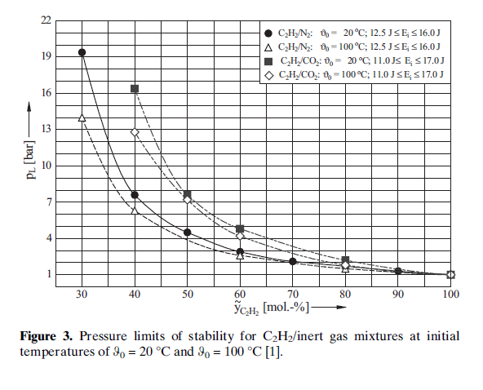
Figure 3: Stability pressure of C2H2 in the presence of diluent gases (N2 / CO2)
The stability pressure of acetylene in the presence of diluent gases H₂ and NH₃ is shown in Figure 4.
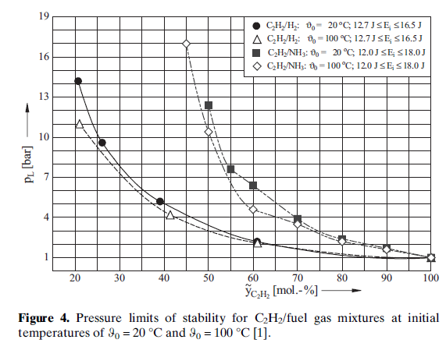
Figure 4: Stability pressure of C2H2 in the presence of diluent gases (H2 / NH3)
It may be deduced that the dilution effect of the various gases is: H2 < N2 < CO2 < NH3 corresponding to the heat capacities of these gases. However, other factors such as the possible reactivity of acetylene with the diluent may also play a role in the degree of stabilization by the diluent.
The effect of initial temperature on the stability pressure of acetylene in the presence of ethylene is shown in Figure 5.
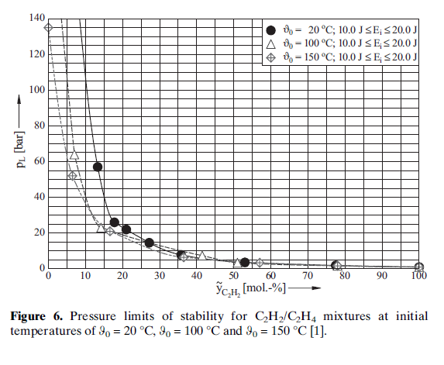
Figure 5: Stability pressure of C2H2 at various temperatures in the presence of C2H4
It is observed that within the experimental temperature range (from 20 to 150 ºC) and the experimental setup boundaries that at high mol % of acetylene (>50%), there is little impact of temperature on stability pressure. At lower mole percentage of acetylene, the stability pressure is high, and the stability pressure decreases with increasing temperature.

Ignition Type and Energy
It was observed and concluded by Schendler [ref 3] and confirmed in the subsequent publication by Holtappels [ref 2] [, that the stability pressure depends strongly on type and amount of energy used, especially for mixtures with low % mole of acetylene (below ~ 20% Acetylene), see Figure 6.

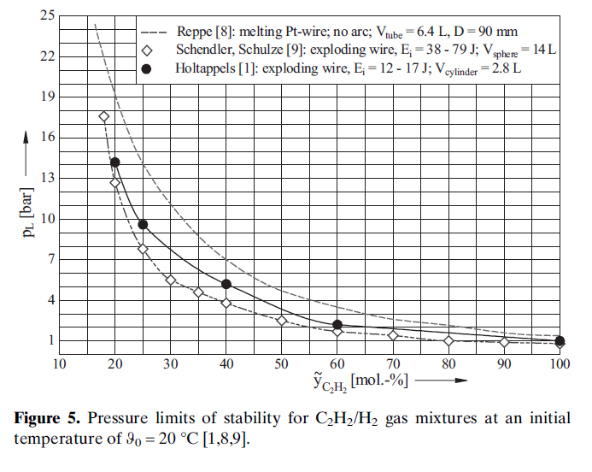
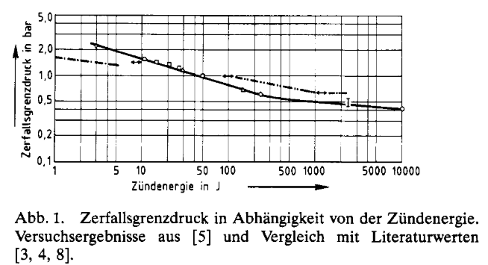
Figure 6: Stability pressure of Acetylene at low concentrations as a function of ignition energy
The effect of the ignition energy on the stability pressure for the C2H2/H2 mixture is shown in Figure 6. Schendler used exploding wire with electrical arc up to 150 J, typically ca 70 J, Holtappels used the same ignition technique but the energy was lower, in the range of 12 – 17 J. Reppe used a melting wire, which does not generate an arc, the supplied electrical energy just melts the wire (most likely Pt wire of 0.3 mm and 10 mm long, it melts in approximately 80 ms (Reppe)), most likely the released energy is the lowest amount of energy of these three experimental studies, but still in range of a few Joules.
It is highly unlikely that such level of accidental energies could be generated in a lab setup which is well bonded and grounded.
The discussed experimental setup in the lab will be bonded and grounded and there are no obvious charge generation mechanisms, and no obvious ignition sources. Therefore, it is unlikely to have an ignition source which would release energy of even one Joule.
In the case of an unknown ignition source (adiabatic compression, catalytically assisted hot spot, etc) the energy release would be expected to be considerably smaller compared to the ignition source used for the above experiments. Hence the stability pressure determined in the experiments are conservative. As a consequence, the stability pressure in the discussed experimental setup is expected to be much higher than those determined by Schendler, Holtappels or Reppe especially in mixtures with acetylene up to 30% mole.

Equipment Geometry
Detonation may occur when flame propagation is above sonic velocities, requiring a certain run-up distance which depends also on the pipe diameter. It is expected that due to small size of vessel and connecting pipes (6mm outer and 4 mm inner diameter Swagelock pipes), the conditions are not favourable for rapid flame acceleration especially with high concentration of diluents. The rupture disk, in combination with the high-pressure strength of the discussed setup should ultimately safeguard the setup by opening and rapid release of the overpressure. Whilst the intention is to operate outside the flammable range, such a situation cannot be fully eliminated in case of a severe process upset.

Analysis of Mixed Gas Composition Chemistries
After the verification the detailed kinetic model (DKM) was used for determination of the temperature required for self-decomposition of the multicomponent mixtures. The selected mixtures present the highest acetylene content and the highest P, T conditions of all considered experimental trials. The following compositions were considered:
S.No. | Hydrogenation Mode
 | P [bara] | T [C] | H2 | CH4 | C2H2 | C2H4 | C2H6 | CO | MA/PD/BD | SUM
1 | 10 | 107.5 | 56.2 | 16.8 | 15.6 | 7.2 | 3 | 0.6 | 0.5 | 99.9
 | Carboxylation Mode
 | P [bara] | T [C] | H2 | CH4 | C2H2 | C2H4 | C2H6 | CO2 | He | SUM
2 | 15 | 121.1 |  |  | 9.5 |  |  | 85.7 | 4.8 | 100
3 | 15 | 121.1 |  |  | 15 |  |  | 80.2 | 4.8 | 100
 | Hydroxycarbonylation
 | P [bara] | T [C] | H2 | CH4 | C2H2 | C2H4 | CO | CO2 | He | SUM
4 | 10 | 115.8 |  |  | 14.1 |  | 81.1 |  | 4.8 | 100
5 | 10 | 115.8 |  |  | 16 |  | 79.2 |  | 4.8 | 100
 | Cyclotrimerization Mode
 | P [bara] | T [C] | H2 | CH4 | C2H2 | C2H4 | CO | N2 | He | SUM
6 | 8 | 105.8 | 19 |  | 9.5 |  |  | 66.7 | 4.8 | 100
7 | 8 | 105.8 | 19 |  | 16 |  |  | 60.2 | 4.8 | 100
8 | 15 | 150 | 19 |  | 16 |  |  | 60.2 | 4.8 | 100
Table 2: Mixed gas compositions (MA = methylacetylene, PD = 1,2-propadiene, BD = 1,3-butadiene)
The worst case is considered as mixture no 8 as it has the highest concentration of acetylene (16 mol %), and the highest temperature and pressure among the various compositions. For this composition, the temperature at which the mixture starts decomposing was determined. The results are given in Table 3 below:
T0[K] | T0[C] | IDT[s]
550 | 277 | >600
650 | 377 | >600
675 | 402 | >600
700 | 427 | >600
705 | 432 | 496
710 | 437 | 399
715 | 442 | 323
720 | 447 | 262.7
725 | 452 | 214
750 | 477 | 80.9
775 | 502 | 32.95
800 | 527 | 14.25
Table 3: Mixture 8 decomposition as a function of temperature (P=15 bara)
It is seen that, in the adiabatic system, the worst-case mixture 8 (at P0 = 15 bara) starts self-decomposing in 10 min at 432°C (causing the temperature increase of ca 770°C). This temperature threshold is considerably higher than 150°C (worst case temperature increase after compression – adiabatic compression). AutoDecomposition Temperature (ADT) of pure acetylene is 635 °C, dilution by an inert gas increases ADT of the mixture. Therefore mixture 8 is not expected to self-decompose when the temperature reaches 150 °C due to compression. The conclusion is reinforced by the fact that the real system is not adiabatic as considered in the calculations. Some heat generated will be dissipated leading to lower temperature rise. The model has been extensively validated for other compositions as given in [Ref 7] and [Ref 8]

Therefore, self-decomposition due to compression is not expected under normal operation conditions of the system i.e. when the considered mixtures are compressed to maximum temperature of 150°C and 15 bara.

The flammability of all the mixture compositions was assessed by comparison to literature data (see Figures above etc) to understand a potential worst-case consequence when a mixture is accidently ignited by unknown ignition source. The analysis was carried out in the same way as for the batch reactor setup [Ref 1] and the results are shown below. Note that Pmax calculations were carried out as given in [Ref 9]:
Mixture no | Flammability | Pmax (bara)
1 | NOT flammable | 38.9
2 | NOT flammable
3 | NOT flammable | 39.1
4 | NOT flammable but close to flammability | 39.4
5 | Potentially slightly flammable | 40.9
6 | NOT flammable
7 | NOT flammable
8 | NOT flammable | 58.3
Table 4: Flammability of various compositions
Only one mixture (no 5) might be slightly within the flammability range at conditions given in Table 2 based on the methodology for the batch setup. All other mixtures are not flammable. Hence, a sustained flame propagation is not possible in these non-flammable mixtures. In the case of the presence of a strong ignition source the decomposition flame may propagate but would be of low severity. Note that the existence of such an ignition source of very high energy (ca 10 – 20 J), is unlikely given that the system will be well grounded/ bonded. Even if it is assumed that such energy is released inside the equipment, for a sustained flame propagation, energy released by combustion must by greater than rate of the heat loss. The use of a very small internal diameter (only 4 mm) assures rather large heat losses (surface to volume is large), therefore such a flame could be quenched. If not, the mode of decomposition should be deflagration (not detonation). The strength of the metal parts is greater than explosion pressure.
The function of the bursting disc is to provide last line of defence against overpressurisation of the system (blocked outlet etc) and the threshold set pressure of the bursting disc to be set 20 – 30 % above normal operating pressure.
The bursting disc currently opens at 45 bar, but it is proposed to lower the opening pressure to e.g. 20 - 30 % above the normal operating pressure to allow release of the combusting mixture (value below the explosion pressure and well above the highest normal operating pressure of 15 bar).
In case of a blocked outlet scenario (due to inadvertent closure of the discharge valve), the acetylene decomposition is possible. However, such scenario is safeguarded by the opening of the bursting disc being set at max 20 bar. Robust procedures should be put in place to ensure the rupture set pressure is selected correctly for a mixture which can release energy due to a chemical reaction (combustion, decomposition, etc.)

For a mixture which has no risk of explosion / decomposition (stable), but the scenario of overpressure is still credible due to well understood scenarios (blocked outlet), the bursting disc set point may be set to the design pressure of the system.

Options Considered
Considering the fact that all considered acetylene mixtures as per table Table 2 are not expected to decompose at the compressor outlet and are mostly non-flammable (except 5, which is slightly into the flammable range), there is a low likelihood of uncontrolled energy release by Acetylene, a catastrophic event as rupture of part of equipment is safeguarded by the bursting disc.
The following equipment options are proposed:
      - Compressor without enclosure
      - Compressor with enclosure to contain flying equipment pieces when ruptured and containing a rupture disc.
      - Compressor inside a blast wall to contain ay overpressure due to detonation / deflagration
      - Unit located in the EPP area to avoid damage to building
      - Increased design pressure of the system to cater for detonative overpressure

Justification for the Chosen Option
Option 1 contains enough safeguards (design pressure, RD) to protect the equipment against overpressure. However, there is an opportunity to further reduce the residual risk to personnel by providing a polycarbonate enclosure. The cost is proportional to the risk reduction => option 2.
Option 2 is the preferred option as the cost of the polycarbonate enclosure is low and it gives extra level of protection to personnel, for a case of rapid pressure build-up leading to vessel rupture. A polycarbonate enclosure is recommended to contain flying pieces.
Option 3 is not justified given the extremally low probability of decomposition and the high cost (and complexity of operation) of having a blast wall to contain overpressure.
Option 4 may be impracticable from constructability / operability perspective and it brings new concerns (outside operation leading to weatherproof design) which are not proportional to the risk reduction.
Option 5 is not preferred will lead to high cost of the unit. The analysis in the document shows that even if decomposition occurs, it will be deflagrative in nature.

Uncertainties and Escalation Ladder
Since acetylene is an unstable molecule and there is limited data available across industry, there are uncertainties involved. Despite the best attempt to de-risk the acetylene chemistries, there is a residual risk of decomposition of acetylene in the system. The figure below shows the escalation ladder for acetylene (the same as for any other HC/air or HC/O2 system), which can lead to explosion at the end. It shows the favourable factors at each stage, which should mitigate the risk of further escalation.
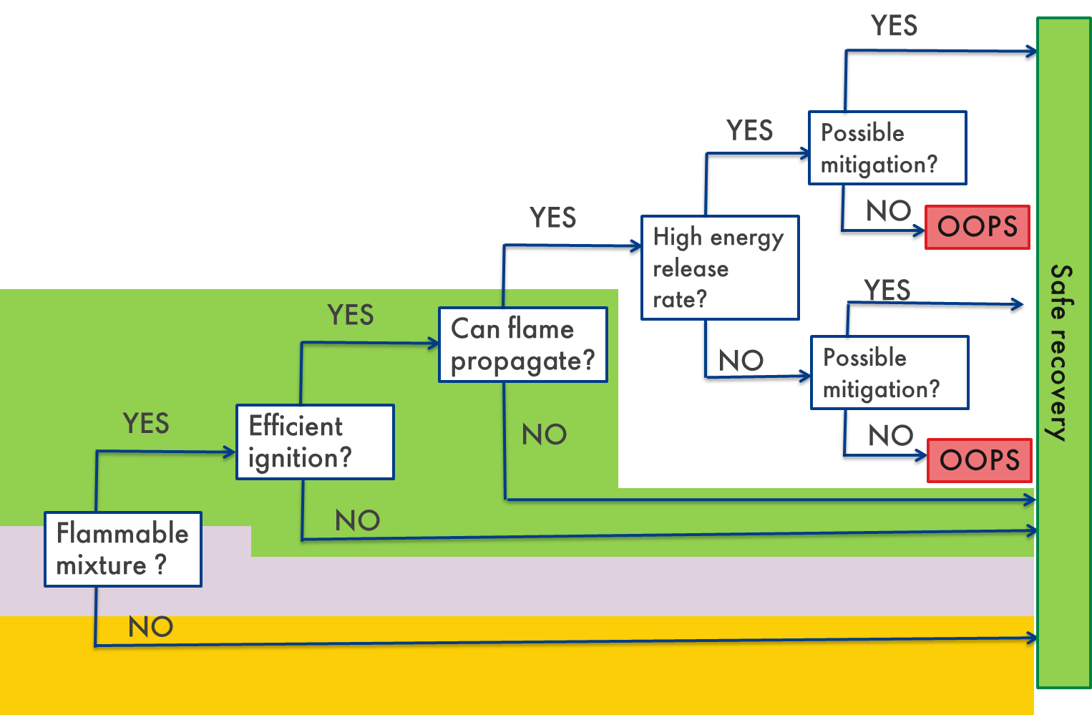
Figure 7: Escalation ladder for acetylene decomposition leading to deflagration
As per the conclusions drawn in the document based on experimental conditions, the operation is expected to be outside the flammable region of acetylene mixtures because of dilution, except mixture 5. If the mixture reaches the flammable region due to the unknowns involved, there is no powerful ignition source available due to the well-grounded/bonded system. Even if such an ignition source exists, the flame propagation may not be sustainable because of the small diameter of connections (internal diameter of 4 mm). If the flame propagation does occur, it should be deflagrative combustion which is characterised by a low rate of pressure rise/energy release (see experimental values of ref 2 Holtappels). The overpressure is within the design pressure system except the quartz reactor. Rupture disc is installed to provide safeguarding against rise in pressure beyond the safe operating region. Potential rupture of quartz reactor may generate fragments which are captured by the furnace enclosure around the reactor.

Requirements/Recommendations
- Unit must be properly grounded/bonded to prevent static charge accumulation
- Rupture disc at the discharge of the compressor to be set at a pressure which is slightly above required operating pressure (20 - 30 %), to prevent inadvertent build-up of pressure due to energy release by acetylene decomposition.
- Rupture disc outlet must be vented to an inert environment to prevent subsequent combustion of released products upon contact with oxygen. Full inerting (to 0 % oxygen) is not necessary, the presence of oxygen at the Limiting Oxygen Concentration is allowed.
- The enclosure may not be fixed to ground, to allow its mobility as it facilitates additional energy absorption upon impact.

Analysis of Pure Acetylene Chemistries
The pure acetylene decomposition characteristics are explored as part of the study for the sole purpose of validating the DKM. It is not intended to be a risk assessment for the deployment of pure acetylene chemistries in the unit. If the operation with pure acetylene in batch or continue reactors is deemed to be required in the future, a safety assessment is required, focused heavily on protective barriers.
The analysis is carried out by determining the elevated temperature at which acetylene starts self-decomposing within 10 mins in an adiabatic system assumption, so all heat generated contributes to temperature increase of the gaseous mixture. The most an appropriate detailed kinetic model (DKM) was searched for and selected: the most advanced and promising DKM [Ref 6], where acetylene was considered as one of the reactants. All elementary reactions are included in the model. However, it is not tested for pure acetylene. A verification was carried out to determine the accuracy of the model.
Calculations of temperature at which pure C2H2 starts to self-decompose in 10 min are given below in tables at different initial pressure (P0). Initial temperature (T0) is changed, and the ignition delay time (IDT) is given in the last column. Description “>600” means there was no self-decomposition occurred in 600 seconds.:

P0=1 bara

1000/T0 | T0 [K] | T0 [C] | ID [s]
1.438849 | 695 | 422
1.428571 | 700 | 427 | >600
1.37931 | 725 | 452 | >600
1.333333 | 750 | 477 | >600
1.315789 | 760 | 487 | >600
1.298701 | 770 | 497 | 402.8
1.290323 | 775 | 502 | 330.9
1.282051 | 780 | 507 | 272.6
1.265823 | 790 | 517 | 186
1.25 | 800 | 527 | 128
1.212121 | 825 | 552 | 53.32
1.176471 | 850 | 577 | 23.38
1.142857 | 875 | 602 | 10
1.111111 | 900 | 627 | 5.286

      - P0=2 bara
1000/T0 | T0 [K] | T0 [C] | ID [s]
1.438849 | 695 | 422 | >600
1.428571 | 700 | 427 | >600
1.37931 | 725 | 452 | >600
1.333333 | 750 | 477 | 391
1.315789 | 760 | 487 | 257.4
1.298701 | 770 | 497 | 171
1.290323 | 775 | 502 | 140
1.282051 | 780 | 507 | 114

      - P0=5 bara
1000/T0 | T0 [K] | T0 [C] | ID [s]
1.680672 | 595 | 322
1.666667 | 600 | 327 | >600
1.6 | 625 | 352
1.538462 | 650 | 377 | >600
1.481481 | 675 | 402 | >600
1.428571 | 700 | 427 | >600
1.37931 | 725 | 452 | 420
1.333333 | 750 | 477
It can be seen that, in 10 min, the decomposition temperature is approximately 497°C at 1 bara, 477°C at 2 bara, and 452°C at 5 bara. This temperature is higher than the maximum temperature attainable at the compressor discharge section. Hence, likelihood of decomposition of pure acetylene is remote.
The calculations were verified against paper of Cullis [1963] [Ref 5] which investigated pyrolysis of pure acetylene (so the self-decomposition) at temperature range from 500 to 1000 °C and atmospheric pressure. The lowest noticeable decomposition of acetylene occurred at 500°C. The agreement with the experimental value obtained in a well-defined laboratory conditions is considered as very good. It is worth mentioning that the Temperature (AIT), i.e., the lowest temperature at which the most sensitive acetylene air mixture undergoes self-ignition is around 320°C. However, temperature at which pure acetylene undergoes self-decomposition called Auto-decomposition Temperature (ADT is 635°C. As expected, presence of air lowers the ignition temperature, the effect is significant: 300 °C. difference. In the absence of air, in a non-adiabatic measurement system the ADT is 635°C (at atmospheric pressure). Hence, the theoretical prediction is relatively accurate. The corresponding documents indicating the ADT, AIT values are given in [Ref 10], [Ref 11], [Ref 12], [Ref 13].

References
      - Patel, P.; Urade, V.; Horton, A.D.; Acetylene ALARP Demonstration for Batch Reactor Setup (Approved - to be published)
      - Holtappels, K; Schönbucher, A.; Inert gas influence and fuel gas influence on the pressure limits of stability of acetylene Chem. Eng. Technol. 2003, 26, 1142
      - Schendler, T, Schulze, H.P. Stabilitätsgrenzdrücke von Acetylen/Gas-Gemischen Chem.-Ing.-Tech, 1990, 62, 41
      - Reppe, W. Chemie und Technik der Acetylen-Druck-Reaktionen Chem.-Ing.-Tech. 1950, 22, 273
      - Cullis, C.F., Franklin, N.H. The Pyrolysis of Acetylene at temperatures from 500 to 1000 ºC, Proc. Royal Soc. London, Ser. A, Math. and Phys. Sci, 1964, 280, 139
      - Detailed Kinetic Model (NUIG, Lokachari, 2019])
      - Baigmohammadi, M.; Patel, V.; Martinez, S.; Panigrahy, S.; Ramalingam, A.; Burke, U.; Somers, K.P.; Heufer, K.A.; Pekalski, A.; Curran, H.J. A Comprehensive Experimental and Simulation Study of Ignition Delay Time Characteristics of Single Fuel C1–C2 Hydrocarbons over a Wide Range of Temperatures, Pressures, Equivalence Ratios, and Dilutions, Energy Fuels 2020, 34, 3, 3755
      - Martinez, S.; Baigmohammadi, M.; Patel, V.; Sahu, A.B.; Nagaraja, S.; Ramalingam, A.; Heufer, K.A.; Pekalski, A.; Curran, H.J. A comprehensive experimental and modeling study the ignition delay time characteristics of ternary and quaternary blend s of methane, ethane, ethylene, and propane over a wide range of temperature, pressure, equivalence ratio, and dilution”, Combustion and Flame, 2021 (to be published)
      - Pekalski, A.A.; Schildberg, H.P.; Smallegange, P.S.D.; Lemkowitz, S.M.; Zevenbergen, J.F.; Braithwaite, M.; Pasman, H.J. Determination of the explosion behaviour of methane and propene in air or oxygen at standard and elevated conditions, Process Safety and Environmental Protection, 2005, 83 (5 B), 421
      - SDS No.: 000010030152 SAFETY DATA SHEET Acetylene, dissolved; by BOC
      - Safety Data Sheet P-4559 Acetylene, dissolved; by Linde / Praxair
      - SAFETY DATA SHEET (MSDS) ACETYLENE; by Afrox
      - Facts about Acetylene: by BOC

Bibliographic information

Security Classification | RESTRICTED
Report Number
Title | Acetylene ALARP Demonstration for batch setup
Subject
Keywords | Acetylene, safe operating conditions, Safeguarding,
Author(s) | Prakhar Patel  Andrew Horton  Vikrant Urade
Publish Date | November 2020
Export Control
Reviewed by | Andrzej Pekalski
Approved by/Content owner
Issuing Company | STCB

